SESSION TEN: WORKSHEET TWO: ONLINE RELATIONSHIPS
sam’s Story :
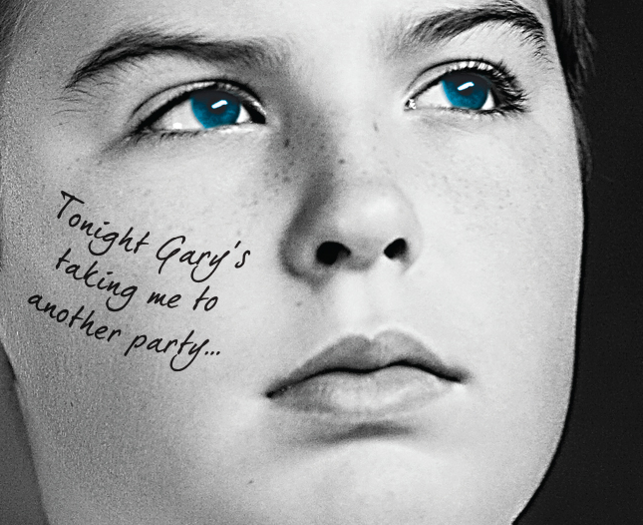
This is a true story of a young person who lives in Lancashire.

I met Gary through Facebook when he came up as a suggested friend. I was 13 at the time and he told me he was 18. I added him as a friend and we started chatting, just having normal conversations.
I started to like him more and more as we got talking and the conversations became quite sexual and we arranged to meet up. I thought I knew a bit about him because he had told me his age and where he lived and sent me a picture, but I know now this was all lies as he was much older than he said and had used a photograph of somebody else.
I was usually really careful online as I have seen all the warnings about internet safety but I kind of just thought nothing would happen to me.
We arranged to meet at a hotel and when we met I realised straight away that something wasn’t right. I went along with things at the start because I really wanted to be in a relationship, and at first he seemed really nice. We started having sex and although by that stage I knew he was a much older man I felt confused and trapped.
Eventually I told my mum what was happening and it was her who called the police. I didn’t want to tell the truth at first, but then I realised he could do the same thing to other people like me and I didn’t want that to happen.
I still use the internet but I don’t do anything like this anymore. I think some young people know how dangerous the internet can be, but there are still a lot who don’t.

