Touchpoint cleaning | - This document is part of the IPC cleaning schedules for domestic staff, day, or night staff.  - Touchpoint cleaning is the areas or surfaces that are touched by a lot of people multiple times during the day.  - Touchpoint surface cleaning and disinfection is widely acknowledged to be the most effective way to stop the spread of infection.  - Touchpoint cleaning is required in order to maintain the appearance of premises and achieve acceptable levels of cleanliness and hygiene. This also reduces transmission and breaks the chain of infection.  - High standards of cleanliness are particularly important in health and social care settings where they are key factor in helping to ensure that people using the care services live with dignity and respect in pleasant surroundings.  - Effective touchpoint cleaning will also help to achieve suitable standards of infection control, particular during outbreaks of illnesses.

- Touchpoints may include:
Elevator buttons. Doorhandles and push plates. Light switches. Bed frames and rails. Commodes. Taps and sinks. Handles, buttons, and dials. Toilet flushes and tables.
Non - Outbreak: Touchpoint cleaning is to be completed a minimum of once a day and recorded below.
Outbreak: Touchpoint cleaning is to be completed a minimum of two times a day and recorded below.
Overview

Cleaning only removes microorganisms rather than killing them.
Cleaning with a general-purpose detergent is usually sufficient for routine cleaning.

There are areas/items of the setting that also require disinfection after use, in addition to cleaning to kill viruses and/or bacteria:
- Sanitary fittings, including commodes and bedpan holders/carriers.
- Food preparation areas

There are occasions that also require disinfection in addition to cleaning to kill viruses and/or bacteria:
- Enhanced clean (during symptomatic service user's isolation period)
- Terminal decontamination (end of isolation period/outbreaks). (See separate document on LCC IPC website).

Definitions

Cleaning | The manual removal of dirt, debris. Micro-organisms are removed rather than killed.  Effective cleaning leaves a surface or equipment visibly clean:  - Clean with a fresh solution of general-purpose neutral detergent in warm water  - This should be changed when dirty or when changing tasks.  REMEMBER! Cleaning is a pre-requisite to effective disinfection

Damp Dusting | The process of removing microorganisms from hard surface, furniture, fixtures and fittings with a damp cloth.  Apply general purpose detergent to a clean cloth and dust the areas. Using a damp cloth soaked in detergent will aid the dust to stick to the cloth rather than being dispersed into the when dry dusting.

Two Step Cleaning Process | Two step cleaning process: is cleaning that needs to be carried out in 2 stages; 1. cleaning, 2. disinfecting.  - First, clean using a detergent and water to remove visible dirt from surfaces and equipment, and then rinse. Secondly, disinfect the item/surface by using a disinfectant. Ensure that the correct dilution and contact time for the product is used.  - *Disinfectants will only work on clean surfaces. Always use a detergent to remove visible dirt and grease before disinfecting.  Disinfection: Process of reducing or eliminating harmful microorganisms from objects and surfaces.  Disinfectant products should contain chlorine at 1000ppm as per the national cleaning standards.  - Any surface disinfectant used in healthcare/social care settings must have been verified by testing according to the British & European standards (BS EN numbers) to support bactericidal and virucidal claims and other healthcare acquired infection (HCAI) pathogens:  - Please look for the BS EN number on the bottle. This is usually displayed on the label and can be located on the front or on the back of the product.  - Disinfectants compliant with BS EN 14476, confirms the product is effective against viruses such as. For enhanced cleaning due to a COVID-19 infection, BS EN 14476 should state that it is effective against enveloped viruses.  - Products compliant with BS EN 1276 or BS EN 13697 confirm the product is effective for preventing the growth and spread of harmful bacteria such as E- coli and Salmonella.  Disinfection products for kitchen and food preparation areas should meet the following BS EN criteria: BS EN 1276 or BS EN 13697.  Decontamination: the term in this document refers to cleaning and disinfection, either using separate cleaning and disinfecting products using a two-step process:  - a general-purpose neutral detergent in warm water followed by solution of 1,000 parts per million available chlorine (ppm available chlorine (av.cl.)  Or  a ‘2 in 1’ product that cleans and disinfects in one step:  - a combined detergent/disinfectant solution at a dilution of 1,000 parts per million available chlorine (ppm available chlorine (av.cl.)

Correct use of product | Products must be used at the recommended dilution rate and contact time to be effective, please follow manufacturer guidance.  We advise that you:  - MUST provide adequate training to staff using any chemical-based products.  - Pay attention to the contact time for the cleaner to be effective.  - Make sure you and your staff follow the instructions for the product chosen.  - Use the correct dilution level for products that need to be diluted before use.  - Supervise staff to ensure that all requirements of the cleaning process are completed.  Remind staff to regularly clean down surfaces, touch points, etc properly, by using the right product, and following the instructions.

How to clean | To minimise recontamination of an area and transfer of virus and other microorganisms, clean from:  - top to bottom.  - clean to dirty areas  - the furthest point to nearest point  - low risk to high-risk pathways.  Staff need to be trained in manual cleaning processes to prevent recontamination of surfaces e.g., clean large and flat surfaces using an ‘S’ shape motion.

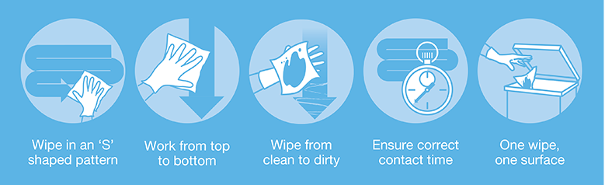

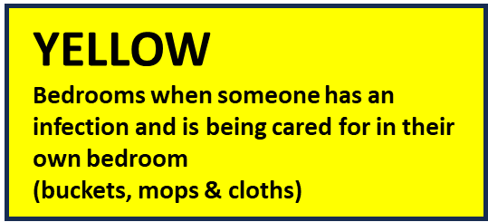
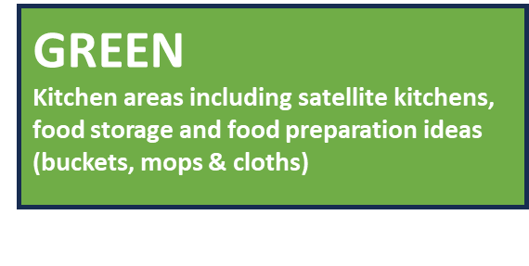
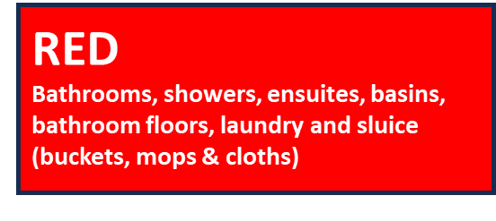
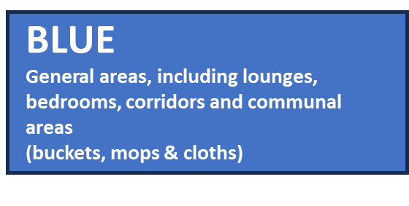

Location: | Date:

 | Time:  (AM)  (PM) | Monday | Tuesday | Wednesday | Thursday | Friday | Saturday | Sunday
Handrails/ Stair rails etc
Door handles
Door Push plates
Light switches
Pull cords
Soap & sanitiser dispensers
Wastebins
Donning and Doffing stations
Lift buttons
Bells/intercoms
Toilet Handle/flushes

PERSONAL CARE EQUIPMENT: | THIS IS IN ADDITON TO CLEANING AFTER EACH RESIDENT USE:

 | Time:  (AM)  (PM) | Monday | Tuesday | Wednesday | Thursday | Friday | Saturday | Sunday
Hoist
Wheelchairs
Stand Aids
Zimmer Frames
Commodes
Weighted Scales
Shower/bath chair
Other

ELECTRICAL EQUIPMENT:

 | Time:  (AM).  (PM) | Monday | Tuesday | Wednesday | Thursday | Friday | Saturday | Sunday
Tv & remote controls.
Radios & any music devices
Tablets
Mobile telephones
Kettles
Toasters
Microwaves
Other
Other

Offices:

 | Time:  (M) Morning.  (L) Lunchtime: | Monday | Tuesday | Wednesday | Thursday | Friday | Saturday | Sunday
Desks
Chairs
Computers
Keyboards
Telephones
Filing cabinets
Drawer handles
Light Switches
Wastebins.
Other

Comments

Manager Signature | Senior | Date

Useful Links and reference guide.

- https://www.england.nhs.uk/national-infection-prevention-and-control-manual-nipcm-for-england/

- COSHH and cleaners - key messages - COSHH (hse.gov.uk)

- Infection prevention and control - Lancashire County Council

- Health and Social Care Act 2008: code of practice on the prevention and control of infections - GOV.UK (www.gov.uk)

- Infection prevention and control in adult social care: acute respiratory infection - GOV.UK (www.gov.uk)

- Care Quality Commission (cqc.org.uk)

- Cleaning effectively in your business | Food Standards Agency

- https://infectionpreventioncontrol.co.uk/wp-content/uploads/2019/07/03-Decontamination-cleaning-and-disinfection-March-2016-Version-2.00.pdf

- https://www.england.nhs.uk/wp-content/uploads/2021/04/B0271-national-standards-of-healthcare-cleanliness-2021.pdf

- https://www.england.nhs.uk/wp-content/uploads/2021/04/B0271-national-standards-of-healthcare-cleanliness-2021.pdf

(Other documents available in our IPC cleaning schedules are - (1) IPC Terminal Decontamination Procedure - deep clean (2) IPC Cleaning Schedule. (3) IPC Resident room cleaning checklist).

