

**Phase 2 Year 2 Data Refresh - September 2022**

**Contents**

|  |  |  |
| --- | --- | --- |
| **Section** | **Description** | **Page** |
|  | **Executive Summary** | **3** |
| **1** | **Introduction** | **4** |
| **2** | **Climate Change challenges and journey towards net zero carbon** | **5** |
| **3** | **Corporate Priorities and Alignment to the Local Transport Plan (LTP)** | **6** |
| **4** | **Department for Transport (DfT) funding and self-assessment** | **7** |
| **5** | **Maintenance backlog and funding apportionment** | **7** |
| **6** | **Performance Management** | **9** |
| **7** | **Customer Feedback** | **11** |
| **8** | **Revised Asset Condition Data** | **12** |
|  | **A, B & C Roads** | **13** |
|  | **Unclassified Roads** | **15** |
|  | **Footways** | **18** |
|  | **Capital Programme Prioritisation** | **20** |
|  | **Bridges and Similar Structures** | **23** |
|  | **Retaining Walls** | **24** |
|  | **Street Lighting** | **25** |
|  | **Traffic Signals** | **26** |
| **9** | **Service Standards** | **28** |
| **10** | **Conclusion** | **31** |

**Transport Asset Management Plan – Data Refresh September 2022**

**Executive Summary**

The Transport Asset Management Plan (TAMP) was approved by the Cabinet Member for Highways and Transport on 10 June 2014 and identified the key strategic priorities of the county council, as the highway authority for Lancashire, during the period 2015/16 to 2029/30.

TAMP Phase 1 ran from April 2015/16 to March 2020. During this phase our focus of attention was the A, B & C and Footway assets. As a result of works carried out over this period the condition of both these assets as measured by SCANNER (A, B & C Roads) and defects (Footways) showed an improvement.

As we moved into Phase 2, our life cycling modelling suggested that additional works were needed to the A, B & C out in order to maintain the progress made in Phase 1 and that the Unclassified Roads which are the focus of Phase 2, are in a poor condition.

The financial constraints that we experienced in Phase 1 are now more acute following a further reduction in funding from the Department of Transport. Throughout Phase 1 we adopted an approach whereby the underlying condition of the network was addressed via the use of early intervention preventative maintenance strategies, as we believed this would enable us to make more efficient use of our resources and this will continue into Phase 2.

This approach has seen improvements in the condition of our A, B & C roads which are now in a better condition than they were in 2009 and since 2014, we now have 503 km less of 'red' or 'amber' sections of road which is a reduction of almost 43%.

More than a quarter of the unclassified residential and unclassified rural roads are end of life (RED) and this backlog will not be addressed before the end of Phase 2 (March 2025) or even by the end of the TAMP (March 2030) without substantial investment. At the same time, we have been able to currently maintain most many of other assets in a similar condition to what they were in 2015, though the condition of the street lighting columns and traffic signal sites is starting to decline; however the scale of the backlog for all asset groups is now becoming apparent as result of Lifecycle Modelling and the overall TAMP objective of getting all assets to a 'good' standard by the end of the TAMP period is unlikely to be met

Emerging problems have been identified with regards street lighting and traffic signal equipment which are showing signs of increased decay due to insufficient funding to address the backlog. Increased column testing (lighting) and funding (signals) are being used to risk manage these assets.

Using the TAMP methodology outlined in Section 10, the overall condition of our highway and transport assets score has been adjusted to take account of the change in Service Standards for Phase2 of the TAMP. The score has reduced slightly from last year and is now down from 3.24 to 3.11 which means that overall condition of our assets is regarded as being FAIR. Real progress is improving the condition score of our assets dependent upon the condition of our unclassified roads improving as they are our greatest value asset in poor condition.

The principal challenges facing us are:

1. How to address the back log in the unclassified network in Phase 2 of the TAMP whilst maintaining the other asset in a safe condition
2. Understand the backlog for Street Lights, Traffic Signals and Structures and develop an approach to manging these whilst seeking funding sources
3. Develop and understanding of the impact of Highway Maintenance activities on carbon (CO2e) generation and develop strategies to reduce this during Phase 2 of the TAMP and develop a provisional plan to work towards net zero.

A further report will be produced once we have developed further our understanding of the backlog and the implications for future funding and the road to net zero through lifecycle and carbon modelling.

1. **Introduction**

The Transport Asset Management Plan (TAMP) was approved by the Cabinet Member for Highways and Transport on 10 June 2014 and sets out how the county council intends to manage its transport assets over the 15-year period from 2015/16 to 2029/30.

In order that the TAMP can remain a live and current document we have provided provide annual updates which contain additional information to supplement the TAMP. It is intended that these updates will provide a summary of external pressures within the highway sector and internal initiatives that will impact of the county council's highway and transport asset network. This update relates to the second year of TAMP Phase 2, and includes information relating to:-

1. Climate Change challenges and journey towards net zero carbon
2. Corporate Priorities and Alignment to the Local Transport Plan
3. Department for Transport (DfT) funding 2022-2025
4. Maintenance Backlog Assessment and funding apportionment
5. Performance Management Information
6. Customer Feedback
7. Revised asset condition data
8. Overall Condition Assessment
9. **Climate Change challenges and journey towards net zero carbon**

In December 2020, Full Council adopted a resolution to set out on an ambitious carbon reduction and nature recovery strategy that seeks to 'transition the Lancashire economy away from carbon by 2030 and address the biodiversity crisis'.

The Climate Change Act requires the UK government to set legally-binding ‘carbon budgets’ which act as steppingstones towards the 2050 target. The first five carbon budgets have been put into law and run up to 2032. The UK is currently in the third carbon budget period (2018 to 2022). The Climate Change Committee has published its advice on the [Sixth Carbon Budget](https://www.theccc.org.uk/publication/sixth-carbon-budget/) and [Government legislated for this in June 2021](https://www.gov.uk/guidance/carbon-budgets#setting-of-the-sixth-carbon-budget-2033-2037).to achieve a 78% Reduction of net emissions below 1990 levels by 2035.

The Highways Decarbonisation Strategy, approved by Cabinet in April 2022, has been developed to reflect this 2035 carbon budget and the Full Council resolution and to support the Corporate Priorities, in particular the need to protect our environment by putting in place a Strategy to achieve a realistic carbon reduction from highways maintenance and highway related activities.

Strategy areas have been developed, which include:

* Promoting a low carbon approach to procurement.
* Measuring the impact of highway maintenance activities and publishing carbon baseline and impact assessments.
* Aiming for lowest carbon impact across the lifecycle of the asset by using carbon lifecycle modelling to inform decisions.
* Ensuring carbon impact of revenue and replacement activities are considered.
* Working towards Net Zero across depots and fleet operations.
* Working with partners to promote innovation.

These represent the county council's high-level commitment to decarbonisation.

The Highways Decarbonisation Strategy describe how the county council will go about delivering Highways’ contribution towards the Council's strategy that seeks to 'transition the Lancashire economy away from carbon by 2030 and address the biodiversity crisis'; acknowledging the successes already achieved by converting street lighting to LED and utilising recycling opportunities.

In the shorter term, the county council must be proactive in targeting ‘quick win’ opportunities that reduce carbon in day-to-day operations, particularly amongst the most energy intensive operations; reviewing traditional highways operations and prioritising activities that have the greatest source of carbon footprint. For example, pavement renewal and surface dressing. The 'road map' identified activities that will help to work towards decarbonisation through to 2035.

Carbon Action Plans have been developed with specific activities to be delivered within the first five years of the plan. These will be closely monitored and reviewed. Progress reporting will be done via Carbon Dashboards included in the annual Transport Asset Management Plan Refresh documents.

For the 2022/23 carriageway capital programme we have assessed the carbon impact of the programme and the savings made by utilising recycling and other low carbon materials and processes, which will save 267 tonnes of CO2e (Carbon Dioxide equivalent); repressing a 15% saving overall, equivalent to 1,342,048 miles driven by an average passenger vehicle.

The Street Lighting LED replacement programme is now entering the final phases. Since 2009 the council has already reduced carbon emissions cumulatively by over 86,400 tonnes, reducing carbon emissions annually from 35,000 tonnes to 5,000 tonnes. Saving almost £40m in energy costs with measures such as converting streetlights to using LED lamps. In October 2021 street lighting energy carbon emissions reduced to zero as a result of purchasing green energy.

1. **Corporate Priorities and Alignment to the Local Transport Plan (LTP)**

Here at Lancashire County Council, we are helping to make Lancashire the best place to live, work, visit and prosper and has recently set new Corporate Priorities.

This Transport Asset Management Plan delivers on these ambitions by setting out our commitment from highway maintenance.

| **Corporate Priority** | **Transport Asset Management Plan approach will** |
| --- | --- |
| Delivering better services | by considering the lifecycle of the asset, will ensure sustainability through durability and that best value and least disruption is delivered for everyone. |
| Caring for the vulnerable | ensure all decisions are based on assessment of asset condition and strategic importance and are therefore equitable. |
| Protecting our environment | ensure use of recycled materials is considered where appropriate that that carbon is considered in all decisions and were possible schemes and activities have low carbon impact. |
| Supporting economic growth | ensure the transport network allows the smooth movement of people, goods and services |

Maintaining and managing out highway assets is one of the 7 Priorities and Activities in the current Local Transport Plan (LTP). The LTP states the objective is to "sustain and improve the condition of footways, cycleways, highways and structures so that maintenance can be carried out in a planned rather than a reactive manner" this aligns with the Transport Asset Management approach of moving away from the worst first approach adopting the approach of preventative maintenance based on the condition of the assets and application of lifecycle planning principals. Work is progressing on a joint Lancashire LTP4 with Blackburn with Darwen and Blackpool Councils. The draft document which is currently being revised in light of latest government and TFN policy guidance, and also to ensure alignment with evidence emerging from the Lancashire Plan work and will also include focus on decarbonisation and levelling up measures. The plan will also incorporate any guidance contained in the new Local Transport Plan preparation guidance, soon to be published.   We are aiming for a late summer/autumn public consultation with adoption of LTP4 by December '22. The 2022 Transport Asset Management Plan Refresh will take on board the draft LTP4 recommendations and will be fully aligned by 2023.

1. **Department for Transport (DfT) funding and self-assessment**

In order to encourage local authorities to adopt better asset management policies, strategies and lifecycle planning the DfT introduced changes to the highway maintenance formula funding mechanism.

From 2015/16 each authority was required to undertake a self-assessment against a set of criteria aimed at assessing performance in relation to asset management, resilience, customer, benchmarking and efficiency and operational delivery.

In the first assessment, submitted in January 2016, we considered ourselves to be band 2 authority. As a result of continued progress in 201/17 and onwards, we have considered ourselves to be a band 3 authority which has enabled us to attract 100% of the Incentive funding element. Band 2 authorities are currently only receiving 30% of the Incentive fund.

Our commitments to in the Highways Decarbonisation Strategy relating to understanding the carbon impact of maintenance decisions within the lifecycle of the asset will help us align to anticipated changes with the self-assessment.

The Department for Transport have now confirmed the funding for 2022 to 2025 as detailed below.

|  |  |  |
| --- | --- | --- |
|  | **2021/22 £m** | **2022/25 £m** |
| Highway Maintenance Basic Need | 12.805 | 12.805 |
| Incentive Fund (assumes Band 3) | 3.201 | 3.201 |
| Pothole Action Fund | 12.805 | 12.805 |
| **Total** | **28.811** | **28.811** |

The assurance of funding for the next three years is welcome and does allow us to plan in the medium term. The next section will examine how we propose to apportion these funds to deal with the maintenance backlog.

1. **Maintenance backlog and funding apportionment**

Work continues through lifecycle planning to predict the condition of the asset groups under various funding levels. The table below covers the level of funding required per annum to improve the asset condition (* Sustainable investment pa) and the one time only cost to clear backlog (** Backlog clearance cost).

| **Asset Type** | **Sustainable investment pa** | **Backlog clearance cost** |
| --- | --- | --- |
| ABC Roads | £17.5m | £280m |
| Unclassified roads: Urban & Rural | £20.7m | £420m |
| Footways | £6.8m | £109m |
| Drainage | £6.8m | £63m |
| Street Lighting Columns | £6m | £52m |
| Traffic Signals | £2.2m | £33m |
| Bridges & Structures | £15m | £172m |
| Retaining Walls | £9.37m | £83m |
| Vehicle Restraint Barriers | £0.200m |  |
| Safety cameras | Unknown | Unknown |

The assurance of funding from the Department for Transport for the next three years is welcome and does allow us to plan in the medium term.

Proposed apportionment for remainder of TAMP Phase 2:

As the funding from the DfT is now known until March 2025 it is proposed to apportion the funds for 2023/24 & 2024/25 in a similar way as for the current year 202/23.

This will allow the:

* continued investment in the Urban Unclassified roads and maintain the standard of the ABC road network for the remainder of Phase 2, as per TAMP priorities for Phase 2,
* continue investment in the Localised Deterioration Fund to support the management of structural defects and reduce member concerns.
* maintain investment in drainage at an appropriate level
* increase the investment in street lighting column replacement, allowing the Highway Service to increase capacity over a two year period.
* increase the investment in traffic signal replacement
* allow sufficient funds for Bridge and structure risks assessments to inform the development of a work bank for the increased investment in bridges and structures in Phase 3 of the TAMP.

Proposed apportionment for TAMP Phase 3:

The level of funding is not yet known beyond March 2025. For the purpose of proposing apportionments for Phase 3 of the TAMP it is assumed the same level of funding will be available.

When considering future funding for Phase 3 it should be acknowledged that the original TAMP objectives of getting the unclassified road network in good condition by the end of Phase2 will not have been met and there will be a need to have an approach that blends the objectives of phase 2 and phase 3 together beyond March 2025 with:

* continued investment in the Unclassified Road network to further reduce the backlog
* continued investment in the ABC road network to maintain it in a good state
* increase further the investment in street lighting column replacement and traffic signal junction renewal
* increase investment in bridges and structures, as per TAMP Phase 3 priority

1. **Performance Management Information**

When the TAMP was introduced in 2014 our emphasis shifted to the use of early intervention preventative maintenance strategies, as we believed this would enable us to make more efficient use of our resources. The emphasis was on collecting condition data for the various highway asset groups to inform investment decisions and to report progress. The condition of the main asset groups as March 2022 is reported further in this document. Additionally, other Key Performance Indicators (KPIs) are collected and reported regularly to the Cabinet Committee for Performance Improvement and the management teams in order to measure the health of the highway service. Below is a summary of those KPIs.

**Carbon Footprint 2021/22**

|  |  |  |  |  |
| --- | --- | --- | --- | --- |
| **Activity** | **CO2e T footprint** | **CO2e T saved** | **Comment** | **% Saved** |
| Street Lighting Energy | 0 T | 3926 T | Purchase of green energy means 0TCO2e foot-print. 15,691 T if had not converted to LED | 100% |
| Street Lighting Column replacement | 652 T |  | Replace concrete by steel |  |
| Carriageway capital programme | 2957 T | 709 T | 3666 T if using traditional materials | 19% |

**Highway Safety Inspections**

An important aspect of this is identifying defects at an early stage in order that repairs can be carried out quickly to stop assets from deteriorating further which may then lead to more expensive repairs being required or increased incidence of injury, damage and third part claims.

In order that we can do this we aim to maintain all aspects of our highway network with specified timescales as set out in our Highway Safety Inspection Policy which can be accessed [here](https://www.lancashire.gov.uk/council/strategies-policies-plans/roads-parking-and-travel/highway-asset-management-in-lancashire/strategies/highway-safety-inspection-policy/).

Our Highway Safety Inspectors look for a range of defects affecting the carriageway, footway, streetlights, signs, bollards and trees.

|  |  |  |  |  |  |
| --- | --- | --- | --- | --- | --- |
| **Highway Safety Inspections** | | | | | |
|  | **2017/18** | **2018/19** | **2019/20** | **2020/21** | **2021/22** |
| Number of Inspections | 34,567 | 35,788 | 34,834 | 34,843 | 33436 |
| Number on time | 30,473 | 26,142 | 28,337 | 33,286 | 30016 |
| % on time;  Target 90% | 88.16% | 73.05% | 81.35% | 95.53% | 89.77% |

**Highway Safety Defect Repairs**

Having either found a defect, or having a defect reported by members of the public, its important these are fixed as within the timescales specified in the Highway Safety Inspection Policy.

The table below shows our performance over the past 5 years: -

|  |  |  |  |  |  |  |  |
| --- | --- | --- | --- | --- | --- | --- | --- |
| **All Safety Defects by Financial Year** | | | | | | | |
| **Year** | **Total Found** | **Emergency & Urgent (Category 1) – Target 95% fixed on time** | | | **Non-Urgent (Category 2)**  **– Target 95% fixed on time** | | |
| **Found** | **Fixed on time** | **% Fixed on time** | **Found** | **Fixed on time** | **% Fixed on time** |
| **2021/22** | 67587 | 1,346 | 1,158 | 86% | 66,241 | 59,181 | 89% |
| **2020/21** | 58,681 | 1,341 | 1,165 | 87% | 57,340 | 50,645 | 88% |
| **2019/20** | 49,295 | 1,263 | 1,165 | 92% | 48,032 | 44,614 | 93% |
| **2018/19** | 43,848 | 1,335 | 646 | 48% | 42,513 | 35,591 | 84% |
| **2017/18** | 55,166 | 1,793 | 152 | 8% | 53,373 | 35,477 | 67% |

Category 1 defects include those that are extremely hazardous and require either emergency or urgent attention because they pose an immediate danger to highway users.

Category 2 defects are those which are deemed not to represent an immediate or imminent hazard and are categorised according to their likely impact and risk probability.

Repair times for both category of defects are contained in Highway Safety Inspection Policy. A summary of 2021/22 highway defects is provided below: -

* 2021-22 saw an overall increase of 15% in the number of defects found compared with the previous year
* Despite to increase in overall numbers the percentage fixed on time remains largely the same as previous year and 8,377 more defects were fixed on time this year compared with last year
* Increase in numbers predominantly due to more Category 2 defects being identified
* Public reported defects represented 26% of all defects found, down from 31% from the previous year.

**Third Party Claims**

Having an effective Highway Safety Inspection and highway defect repair regime helps us to defend ourselves against third party claims under Section 58 of the Highways Act 1980. Our successful repudiation rates with regards third party / vehicle damage claims are increasing as set out in the table below: -

|  |  |  |  |
| --- | --- | --- | --- |
| **Third Party Claims - Repudiation Rates** | | | |
| **Type of Claim** | **2019/20** | **2020/21** | **2021/22** |
| Personal Injury | 77% | 80% | 85% |
| Vehicle Damage | 56% | 68% | 79% |

There has been an improvement in repudiation rates over the last three years and a reduction in the amount paid out.

**Street Lighting**

During the year we have carried out in the region of 2,800 street lighting repairs that caused the light not to work. Whilst most repairs can be carried out without the need for expensive traffic management a small number do so that staff can work safety.

Where traffic management is not required, we aim to fix 95% of faults require within 5 working days. Where traffic management is required, we aim to fix 95% of faults within 20 working days. The results for both category of repairs is shown below: -

|  |  |  |  |  |  |  |
| --- | --- | --- | --- | --- | --- | --- |
|  | **Non-Traffic Management Repairs: Target 95%** | | | **Traffic Management Repairs; Target 95%** | | |
| Year | Found | Fixed | % Fixed on time | Found | Fixed | % Fixed on time |
| 2021/22 | 2417 | 2368 | 98% | 409 | 389 | 95% |
| 2020/21 | 3006 | 2742 | 91% | 209 | 185 | 89% |

During the year we also carry out a different type of inspections to our street lighting columns. The table below sets out the number of streetlighting inspections in 2020/21 and 2021/22: -

|  |  |  |
| --- | --- | --- |
| **Inspection Type** | **Year** | |
| **Number** | **2020/21** | **2021/22** |
| Column Testing (Structural) | 3,908 | 4535 |

1. **Customer Feedback**

Since 2015 the county council has taken part in the annual National Highways & Transport Network (NHT) survey which collects the public's views on different aspects of highway and transport assets / services in local authority areas.

For 2021 the survey was sent to 4,800 households across the authority area and 1,220 members of the public responded. This represents an overall response rate for Lancashire of 25.4% compared with the national average of 23.8%

**Summary of Key Benchmarking Indicators (KBI) NHT Satisfaction Indicators 2020-21**

|  |  |  |  |  |  |
| --- | --- | --- | --- | --- | --- |
| **Ref** | **Indicator** | **% Satisfied** | **Trend** | **NHT Average** | **Quartile** |
| **Key Benchmark Indicators** | |  |  |  |  |
| KBI23 | Condition of highways | 23% | -2% | 32% | 4 |
| KBI24 | Highway maintenance | 40% | -5% | 42% | 3 |
| KBI25 | Street lighting | 62% | 2% | 62% | 2 |
| KBI26 | Highway enforcement /obstructions | 41% | -1% | 43% | 3 |

Many of our indicators perform well:

|  |  |  |
| --- | --- | --- |
| **Ref** | **Indicator** | **% Satisfied** |
| KBI25 | Street lighting | 62% |
| HMBI05 | Provision of street Lighting | 60% |
| HMBI27 | Cleanliness of road signs | 55% |
| HMBI28 | Undertakes cold weather gritting (salting) | 56% |
| HMQI13 | Provision of streetlights | 79% |

We closely monitor those with the lowest satisfaction scores:

|  |  |  |  |  |  |
| --- | --- | --- | --- | --- | --- |
| **Ref** | **Indicator** | **% Satisfied** | | **NHT Mean** | |
| **Benchmark Indicators** | | |  | |  | |
| HMBI01 | Condition of road surfaces | 24% | | 32% | |
| HMBI13 | Deals with potholes/damaged roads | 26% | | 31% | |
| HMBI23 | Speed of repair to damaged pavements | 35% | | 37% | |
| HMBI24 | Quality of repair to damaged pavements | 40% | | 44% | |
| HMBI30 | Speed of repair to damaged roads | 22% | | 27% | |
| HMBI31 | Quality of repair to damaged roads | 27% | | 34% | |
| **Quality Indicators** | | |  | |  | |
| HMQI11 | Number of potholes | 5% | | 22% | |
| HMQI12 | Action to repair local roads | 29% | | 32% | |

We also take part in the On-Line Highway Maintenance Themed Survey in order to get a broader view of opinion. Below are extracts of the Surveys:

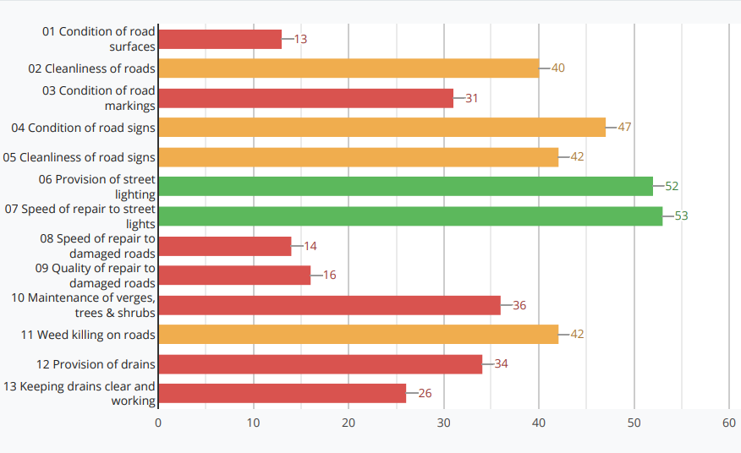

Condition of Road Surfaces, Quality of Repair to Damaged Roads and Speed of Repair to Damaged Roads remain an issue for the majority of residents of Lancashire.

As a result of this feedback over the last few years the county council has undertaken improvements to the way we fix potholes and is introducing improvements in our communications to the public around planned carriageway and footway repairs; including designated webpages explaining various aspects of our approach to carriageway and footway maintenance, which can be found [here](https://www.lancashire.gov.uk/roads-parking-and-travel/roads/).

1. **Revised Asset Condition Data**

Since the TAMP was first introduced in 2014 much work has gone into collecting and updating asset condition data and procedures have now been put in place whereby we are able to collect and refresh this data at intervals that are considered appropriate.

The following pages provide a brief summary of the condition of each of the asset groups covered by the TAMP together with a summary of the main points arising out of our analysis of each group. A full explanation of the service Standards can be found in the TAMP Phase 2 document which can be found [here](https://www.lancashire.gov.uk/council/strategies-policies-plans/roads-parking-and-travel/highway-asset-management-in-lancashire/strategies/transport-asset-management-plan/tamp-phase-2-201920-202324/)

Each section follows a similar basic structure. Where possible graphs will show simultaneously the condition as at the end of Phase 1\ start of Phase 2 and the current condition as of March 2022 (end of Year 2 Phase 2). Where possible this will be broken down on a district by district basis.

A summary provides key bullet points which seek to outline briefly the key facts relating to the category of the asset.

**A, B and C Roads**

**Most Cost-Effective Strategy**: Investment in preventative maintenance using appropriate surface treatments determined through deterioration modelling.

**Approach TAMP Phase 2 and Phase 3:** Maintain the network at the current level through predominantly preventive and preservative treatments

The service standard for this asset grouping is shown below: -



**Summary**

* A: Amber slipped from EXCELLENT to GOOD in terms of TAMP Service Standard – still in range for the higher-level targets
* A: Red slipped from EXCELLENT to FAIR in terms of TAMP Service Standard – still in range for the lower level targets
* B: Red & Amber moved slightly but remained in same TAMP Service Standard band, FAIR and GOOD respectively – Ambers in range for the higher level targets, Reds in range for the lower level targets
* C: Amber & Red considered Fair in terms of TAMP Service Standard and remained in for the higher level targets
* The asset consists of a total of 2,533 km of highway
* The length of A, B and C roads classified as RED or AMBER in 2014 was in the region of 1,180 km.
* According to the May 2022 SCANNER survey the quantity of RED or AMBER has reduced by 503km down to 676km, a reduction of 43%
* The general improvement in the A, B & C road network has returned many of these roads to their pre-2014 condition across all district areas,
* There has been a slight decline in the overall condition of the A, B & C road network compared with previous year
* The proportion of RED or AMBER A, B and C roads varies across the district areas and is shown in the graph below
* Between 2014 and 2022 the Km of RED or AMBER on:-
  + A roads reduced by almost 75 km,
  + B roads reduced by almost 108 km,
  + C roads reduced by neatly 319 km

Provided below are various graphs and charts showing the condition of this asset grouping over time.

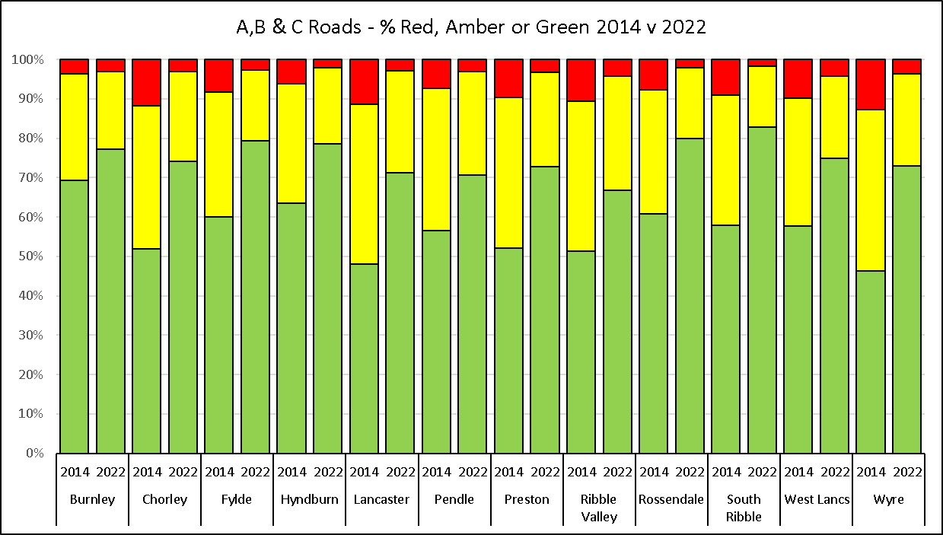

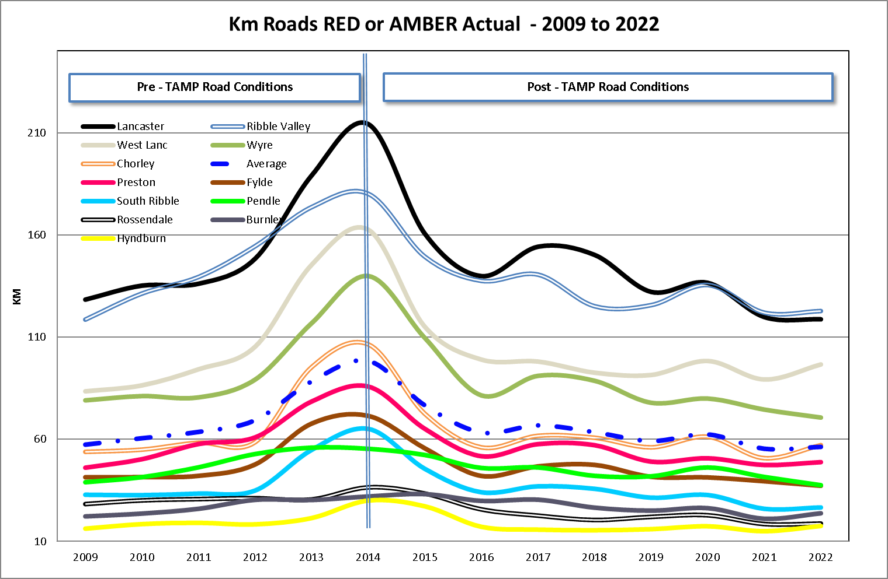

**Unclassified Roads**

**Most Cost-Effective Strategy:** Investment in preventative maintenance which is based on appropriate surface treatment in preference to more costly resurfacing of roads.

New service standards for our Residential Unclassified and Rural Unclassified roads and the footway network where presented to the September 2021 meeting of the Cabinet for approval. These are based Detailed Video Survey. Currently for which no national standards currently exist. The Department for Transport (DfT) have however started a consultation exercise and it is expected that advice will be available before the end of the current TAMP Phase 2.

Therefore, the Service Standards below are provisional and will be updated the outcome of the consultation exercise is known.



**Summary**

* The asset includes approximately 3,440 km of residential roads and 980 rural.
* The rural unclassified and urban unclassified road networks are the main focus of our attention in Phase 2 of the TAMP.
* A new service standard for this asset type was introduced for the start of TAMP Phase 2 and reflects the % of square Kms that are RED or AMBER
* Asset condition is determined by video survey. As this is a different type of survey to SCANNER the results are not directly comparable to the A, B & C road network
* A review is currently taking place by the Department for Transport to help determine common means for expressing carriageway condition across the different mechanisms for measuring condition. This review will help us to develop target conditions for the Unclassified Roads

**Urban Unclassified**

**Most Cost Effective Strategy:** Investment in preventative maintenance which is based on appropriate surface treatment in preference to more costly resurfacing of roads.

For 2022, 26.83% of this network is regarded as RED, 20.29% is AMBER and 52.87% is GREEN and using this condition data is considered to be in a POOR condition

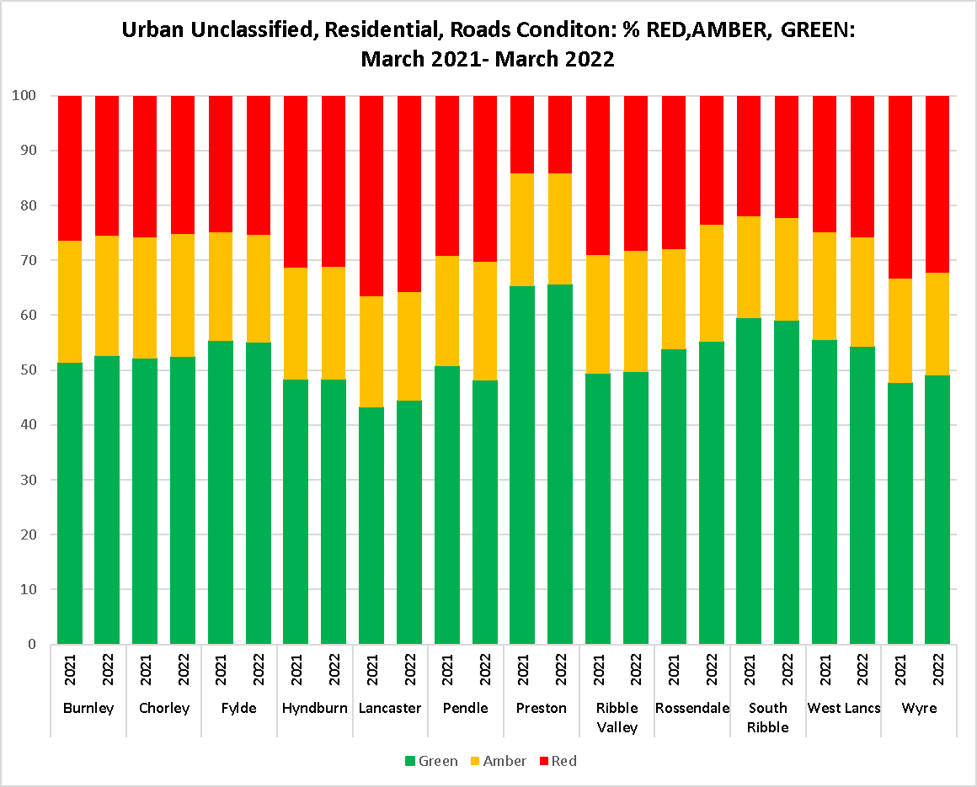

**Approach TAMP Phase 2 and Phase 3:** Arrest the accelerating decline of the urban unclassified 'residential' network through structural capital schemes, focusing on recycling where possible, for those roads showing 95%-100% structurally impaired and? repeat visits to Structural Defects (Potholes), and through the use of the Localised Deterioration Fund to reduce structural defect repeat visits and address local and Member concerns.

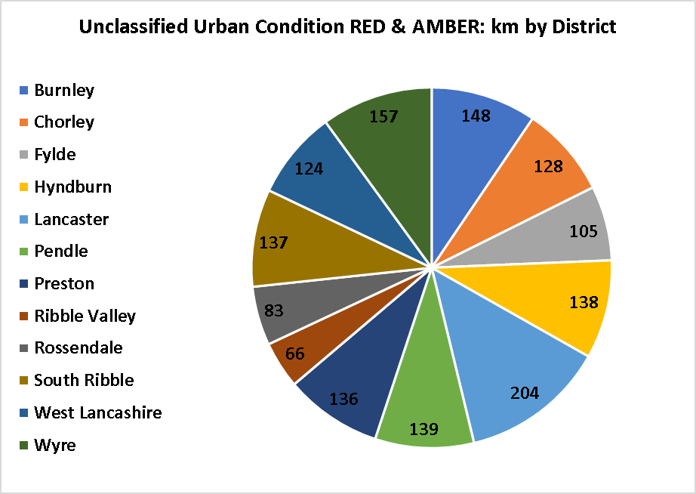

**Rural Unclassified Roads**

**Most Cost-Effective Strategy:** Investment in preventative maintenance which is based on appropriate surface treatment in preference to more costly resurfacing of roads.

* 30.30% of this network is regarded as RED, 20.00% is AMBER and 49.70% is GREEN and using this condition data is considered to be in a POOR condition

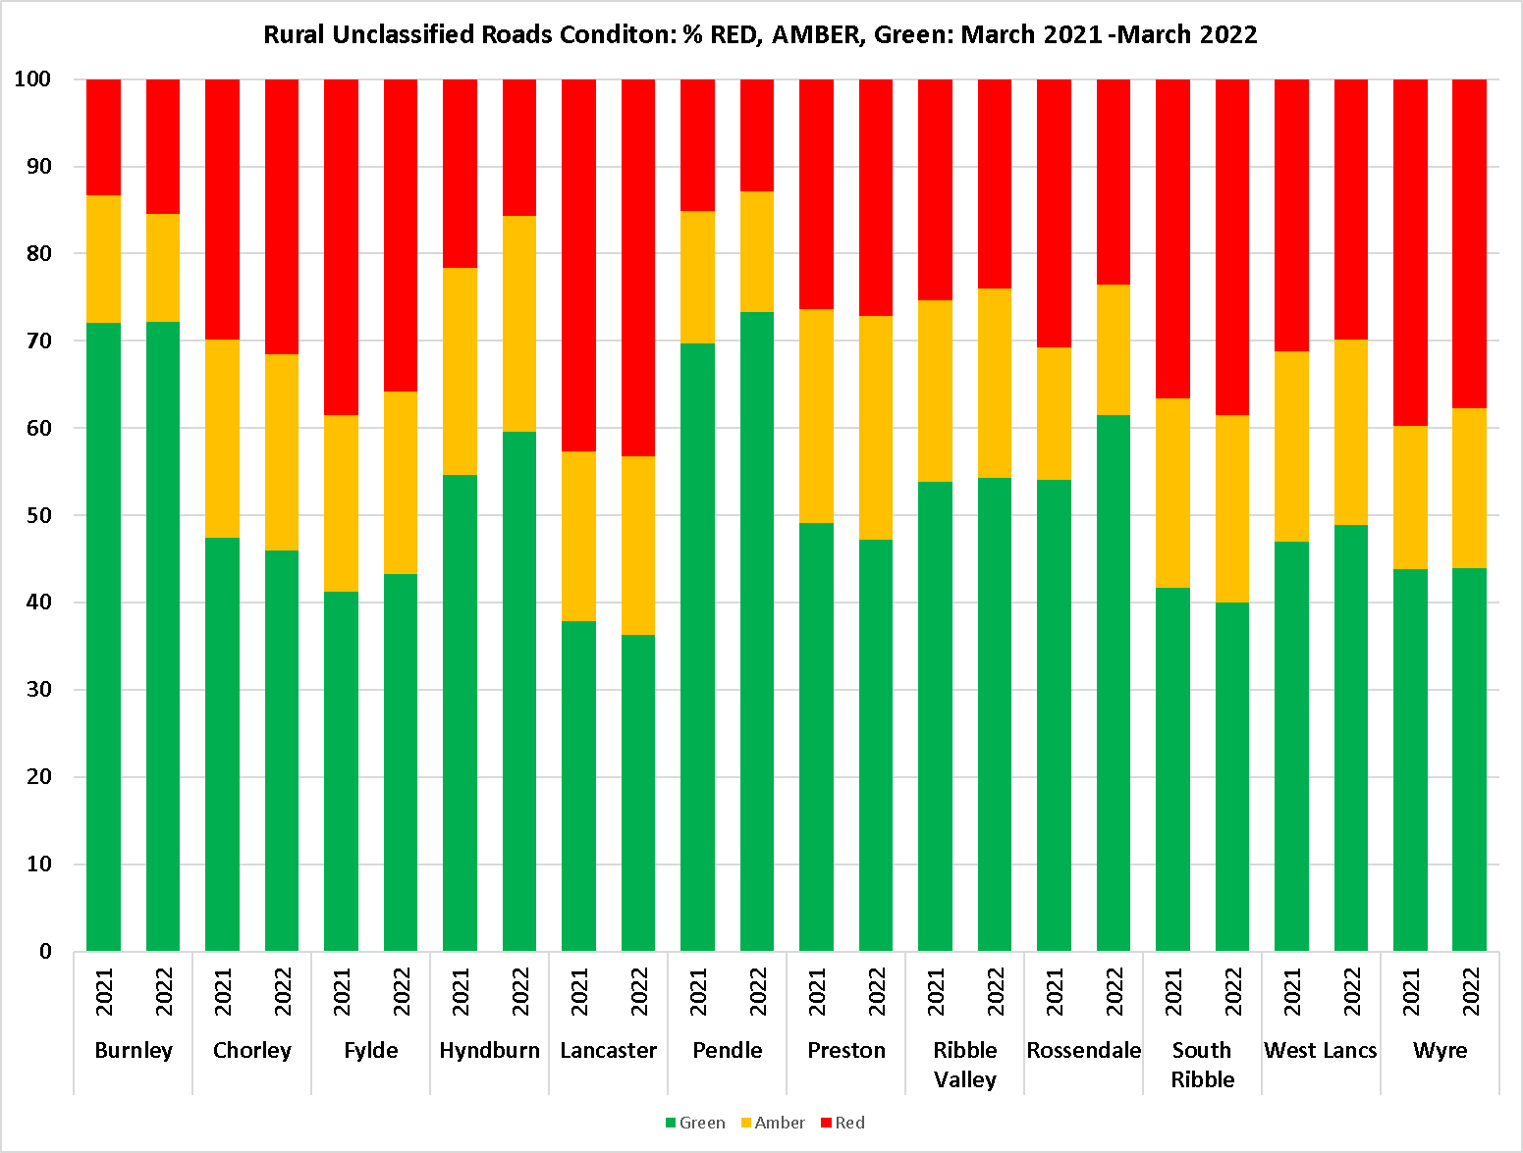

**Approach TAMP Phase 2 and Phase 3:** Maintain the network condition through the use of jet patching to find and fix defects and preserve condition. Structural capital schemes, focusing on recycling where possible, for the worst areas and preventative treatments on the most strategic routes.

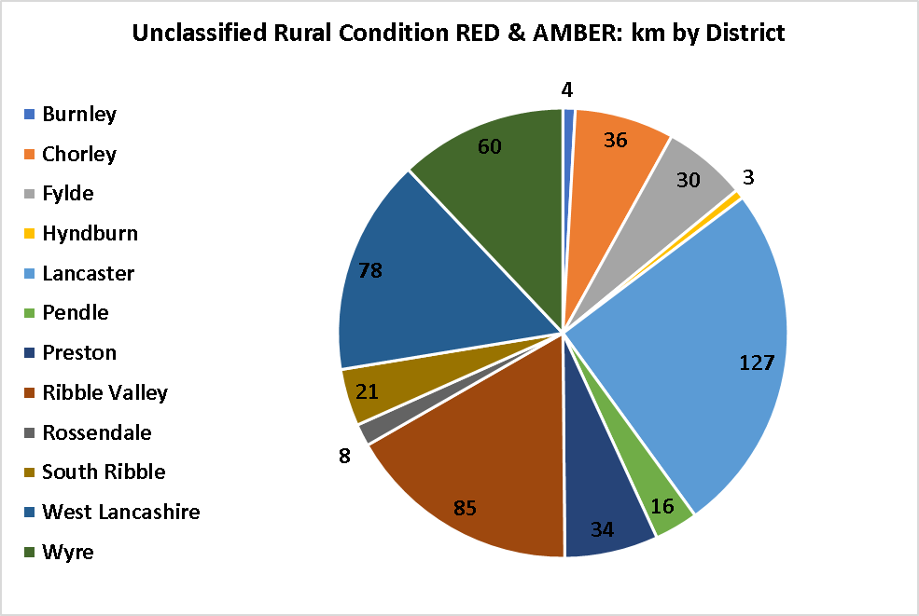

**Footways**

**Most Cost-Effective Strategy:** Investment in preventative maintenance which is based on appropriate surface treatment in preference to more costly resurfacing of footways.

**Approach TAMP Phase 2 and Phase 3:** With available funds focus on the areas of worst condition with greatest footfall for vulnerable users, such as around schools, hospitals. Consideration to be given to areas of high deprivation. Predominantly use of recycled materials.

**Summary**

* Condition data of this asset has been assessed, with effect from April 2020, via video survey.
* Due to several changes since 2014 with regards reporting software and reporting procedures the defects numbers stated in TAMP Phase 1 are not comparable to TAMP Phase 2 figures.
* A review is currently taking place by the DfT to help determine common means for expressing footway condition using different methodologies for measuring condition. This review will help us to develop target conditions for our footway assets. Once we have received this guidance, we will set new service standards.
* Total length of footways is around 7190km
* 12% of our footways are regarded as RED, 40% are AMBER and 48% are GREEN and using this condition data are considered to be in a POOR condition.

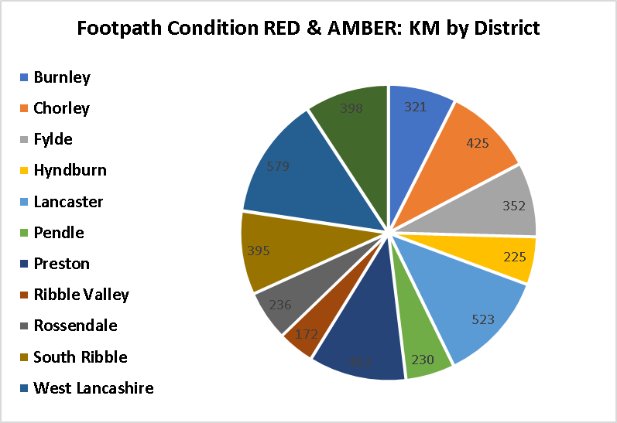

**Capital Programme Prioritisation**

**Condition Data**

Each year a video survey of all of Lancashire's highways is used to assess the condition of all A, B and C classified roads, and every other year for unclassified (residential) and unclassified rural roads. Once the condition survey is undertaken a scheme identifier toolkit is applied to generate indicative scheme proposals, this also includes schemes proposed from stakeholders such as County Councillors, Customer complaints and officers. Two different scheme types are generated depending on condition, resurfacing or preventative (i.e. surface dressing)

The resurfacing programme focus on areas of predominately grade 4 and 5 defects, i.e. structural damage and failure of the carriageway and weights theses grade of condition over all others.

The surface dressing programme focuses on areas of condition grade 3 as general these are the area's most suitable and in the most need of preventative surface dressing work, to delay deterioration into grade 4 and 5.

**Defect Data**

Highway Safety defects, general carriageway defects such as those reported and defects and complaints from the public, are applied to the scheme areas to understand where repeated unplanned repairs and defect reports are being made.

**Strategic Importance**

The importance of a Highway within any proposed scheme is determined by numerous strategic factors and associated perceived risks for the whole or the majority of its extent. These include bus routes, presence of schools or emergency services and the resilient route network.

**A, B and C classified Roads**

* Higher weighting is applied on carriageway condition observations owing to higher traffic flows, higher speeds and therefore greater risk to public and workforce on ABC roads.
* Higher weighting is applied to network significance and less on factors such as number of properties as the purpose of ABC roads is the movement of vehicles over strategic distances.
* An additional weighting multiplying is added to the class of roads that are deteriorating at the fastest rate from the previous year's SCANNER survey which directly influences DfT Road Condition Indicator scoring mechanism for the authority.
* Index of deprivation is not used on ABC roads because classified roads by their nature span multiple areas and their importance goes beyond the immediate extent of the scheme.

**Urban Unclassified Roads**

* Has a balanced approach applying weighting to number of potholes, carriageway condition reports and applies a double weighting to the number of residential and mixed-use properties, with the aim of focusing on densely populated areas where schemes will have maximum benefit.
* Index of deprivation – helps provide a balance to the prioritisation in areas where the submission of public reported defects is less prevalent.

**Rural Unclassified Roads**

* Higher weighting is applied to secondary gritting routes to focus in on where rural settlement hubs are located, similarly, higher weightings are applied to number of residential properties.
* Higher weighting is applied to complaints (public/councillor etc) as we generally get less complaints on the rural network, this still allows the lower number of complaints due to lower population density in rural areas to have an influence.
* Higher weighting applied to bus routes (inc. school bus routes), to ensure resilience of public transport routes between rural settlements and employment and educational areas.

**Summary**

* Yearly condition survey providing 100% coverage of ABC and 50% coverage of unclassified roads.
* 2-year history of defect data assessed against condition data
* Strategic importance and risk factors of network considered
* Programme specific weightings to tailor each programme.
* Focuses on large areas to provide best value and impact
* Life cycle approach which provides a reduction in cost and carbon
* All schemes are confirmed and validated by local engineers
* The data driven approach is transparent and accountable and underpins the selection of schemes across the County

**Local Deterioration Fund**

**Overview**

The Local Deterioration Fund (LDF) was created as a gap that was identified between what repairs were achievable within current revenue budget constraints and what is perceived to be a capital maintenance scheme. Therefore, a process was put in place to ensure the schemes that fell between these two operations could be funded but still prioritised. LDF schemes are generally less 2000m2, which is typically no more than a single day of machine laid resurfacing.

The LDF generally assesses and commissions scheme three times year. This allows a flexible programme to be developed that can better deal with roads that have deteriorated quickly to be resurfaced within year.

The prioritisation of LDF schemes differs from the capital programme in that the strategic importance of the highway is not considered. The number of repeated maintenance visits, defect numbers and stakeholder reports are the main factors. This ensures that areas that are costing the most money to maintain are treated as a priority, thereby reducing the stress on revenue budgets and keeping those areas safe.

The process for assessing, identifying and commissioning LDF schemes through the year is shown right:

**Summary**

* The programme is assessed, and schemes identified and commissioned three times per year
* Weighted by number of repeated maintenance visits, defect numbers and stakeholder reports are the main factors.
* Provides a flexible approach to deal with in year carriageway deterioration
* Helps to smooth out seasonal programme demands on highways operations teams
* Provides high quality, durable capital works standard carriageway repairs to areas of repeated revenue spend
* Reduces revenue spend
* The data driven approach is transparent and justifies spend on smaller areas which require treatment across the County

**Bridges and Similar Structures**

**Most Cost-Effective Strategy:** Investment in preventative maintenance which is not based on reconstruction of bridges but on intervention at the appropriate time.

|  |  |  |  |  |
| --- | --- | --- | --- | --- |
|  | | Average BCI CRIT | | |
| **District** | **No. of Bridges** | **Mar-20** | **Mar-21** | **Mar-22** |
| Burnley | 134 | 80.4 | 80.4 | 79.27 |
| Chorley | 109 | 87.9 | 86.5 | 85.46 |
| Fylde | 49 | 82 | 81.6 | 81.87 |
| Hyndburn | 78 | 70.8 | 69.9 | 71 |
| Lancaster | 269 | 83.2 | 83.4 | 84.02 |
| Pendle | 157 | 83.9 | 83.5 | 83.3 |
| Preston | 143 | 77 | 76 | 75.91 |
| Ribble Valley | 265 | 77 | 77.6 | 77.15 |
| Rossendale | 159 | 78.1 | 77.1 | 77.71 |
| South Ribble | 88 | 78.6 | 77.4 | 76.97 |
| West Lancashire | 254 | 81.9 | 81.9 | 81.86 |
| Wyre | 127 | 85.5 | 84.6 | 84.76 |
| **Total** | **1832** | **80.76** | **80.45** | **80.32** |

|  |  |  |  |  |  |
| --- | --- | --- | --- | --- | --- |
|  |  |  | Average BCI CRIT | | |
| **Maintenance Category** | **Total % Deck Area** | **No. of Bridges** | **Mar-20** | **Mar-21** | **Mar-22** |
| Planned Targeted | 69% | 567 | 79.1 | 78.67 | 78.71 |
| Planned Preventative | 21% | 663 | 80.7 | 80.47 | 80.7 |
| Planned Do Minimum | 10% | 602 | 82.46 | 82.19 | 81.42 |
| **Total** | **100%** | **1832** | **80.76** | **80.45** | **80.32** |

**Approach TAMP Phase 2 and Phase 3:**

* Identify appropriate preventative maintenance to prevent further deterioration.
* Continued investment in the understanding high risk structures such as scour susceptible, post-tensioned, and half-joint, and deliver appropriate interventions before issues arise.
* Identifying high risk bridges producing management plans for each.
* Identifying those assets for replacement or large investment that fall outside of proposed capital allocations.
* Increased lifecycle planning using the Structures Asset Valuation Investment (SAVI) Toolkit to understand the asset condition better and prepare a work bank for Phase 3 of the TAMP.

**Summary**

* We are responsible for just under 1,850 bridges
* We have good condition information relating to this asset type
* The service standard was changed at the start of Phase 2 to calculate bridge condition by maintenance category, so funds can be directed more towards our priority structures.
* The funding level for Phases 1 and 2 of the TAMP was set at a level that should see a steady decline in the condition of the stock and this is being confirmed within the condition figures. There has been a slight fall in the condition of this asset grouping across all maintenance categories over the past 12 months. This is to be expected.
* The condition of our Planned Targeted bridges, which are located on strategic and priority routes and account for 69% of all bridge deck area, is considered to be FAIR.
* The condition of our Planned Preventative & Planned Do Minimum bridges, which account for just 31% of bridge deck area, but 69% of our bridge stock is considered to be GOOD.
* The Bridges asset group will be the focus of attention in Phase 3 of the TAMP. During Phase 2 we are looking to maintain the condition of this asset group as close to their April 2020 condition as possible.
* The backlog of works is increasing. The lifecycle planning using SAVI shows that it will continue to increase despite the increase in funding levels proposed for TAMP Phase 3.
* Implementing management plans for high-risk structures such as scour susceptible, post-tension and half-joint should allow for improved understanding of their deterioration and improve intervention efficiency.

**Retaining Walls**

**Most Cost-Effective Strategy**: Investment in preventative maintenance which is not based on reconstruction of retaining walls but on intervention at the appropriate time.

**Approach TAMP Phase 2 and Phase 3:**

* Identify appropriate preventative maintenance to prevent further deterioration.
* Identifying high risk structures producing management plans for each.
* Identifying those assets for replacement or large investment that fall outside of proposed capital allocations.



**Summary**

* Our knowledge of this asset is incomplete in terms of ownership but is slowly improving. We currently have information relating to 1,406 retaining walls which have a combined length of 124km.
* Condition data for retaining walls is collected using the same inspection methodology as we use for bridges.
* We propose to monitor the condition of this asset using the same maintenance categories as we do for bridges.
* Whilst we are aware that some walls have failed in places, resulting in a low wall condition indicator, many of these occurrences are at sections that are in a stable condition and the land supported has found a natural angle and is also stable. In such instances we do not intend to carry out any repairs unless they start to present a safety issue or support to the highway is compromised.
* As unknown walls are an important fabric of the highway, we are collecting condition data in order to monitor their condition and also get an idea as to the extent of these throughout Lancashire,
* Establishing ownership is not always a straightforward issue to resolve, so due to limited resources we would only seek to establish ownership for walls that require works.
* Whilst we have not yet set a formal service standard for this asset type, they are considered to be in a FAIR condition.

**Street Lighting**

**Most Cost-Effective Strategy:** Planned column replacement programme

**Approach TAMP Phase 2 and Phase 3:** Increased investment in planned column replacement with continued risk-based approach to test the most vulnerable assets and replace or retest as required

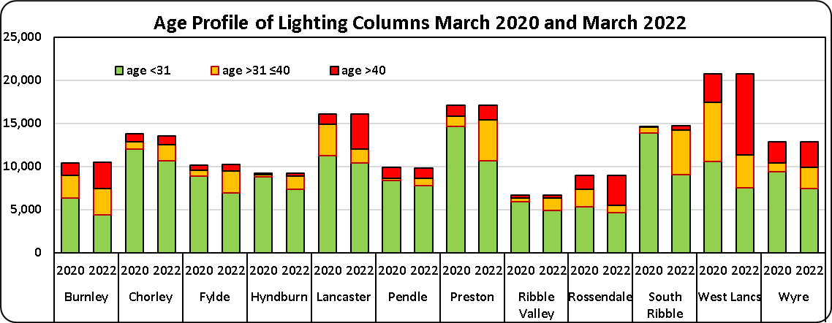

|  |  |  |  |  |
| --- | --- | --- | --- | --- |
| **Service Standard Grade Boundary** | | | | |
| **POOR** | **ACCEPTABLE** | **FAIR** | **GOOD** | **EXCELLENT** |
| >16,000 | 16,000 – 12,001 | 12,000 - 8,001 | 8,000 – 4,001 | <4,000 |

|  |  |  |  |
| --- | --- | --- | --- |
| **Street Lighting Column Service Standards** | | | |
| **Condition Measure** | **Outturn 2019/20** | **Outturn 2021/22** | **Target 2024/25** |
| No. of columns aged over 40 years old | **14,665** | **29,000** | >16,000 |

**Summary**

* We are responsible for approximately 151,000 streetlights and 18,097 illuminated signs, bollards, and similar installations.
* LED replacement works commenced in 2009 and using a variety of funding mechanisms it is anticipated that all our streetlights will be LED by October 2022.
* We spend in the region of £4m per year on electricity to run our streetlights, sign, bollards and traffic signals etc,
* At the end of March 2022, we had 29,000 lighting columns that were aged 40 years or older (19.24% of the total stock), up from 14,665 at the start of Phase 2.
* The increase in numbers relates to 1) columns erected in that time period that have now come of age and 2) some older columns had no clear erection date so were assigned one based on best estimate based on manufacture details or when the road they are on was adopted
* The current condition of the stock is considered to be POOR and is expected to deteriorate further year on year.
* In order to maintain the keep pace with the rate of deterioration it is estimated that a capital investment of the order of £6m per annum would be required.

**Traffic Signals**

**Most Cost-Effective Strategy:** Investment in preventative maintenance which is based on replacement of obsolete units at key junctions which will not be covered by Highways and Transport Masterplan activities**.**

**Approach TAMP Phase 2 and Phase 3:** as above

|  |  |  |  |  |
| --- | --- | --- | --- | --- |
| **Service Standard Grade Boundary** | | | | |
| **POOR** | **ACCEPTABLE** | **FAIR** | **GOOD** | **EXCELLENT** |
| **>270** | **270 - 201** | **200 -135** | **134 - 70** | **<70** |

|  |  |  |  |
| --- | --- | --- | --- |
| **Traffic Signals Service Standards** | | | |
| **Condition Measure** | **Outturn 2020/21** | **Outturn 2021/22** | **Target 2024/25** |
| **No. of obsolete and vulnerable traffic signal sites** | **337** | **395** | **289** |

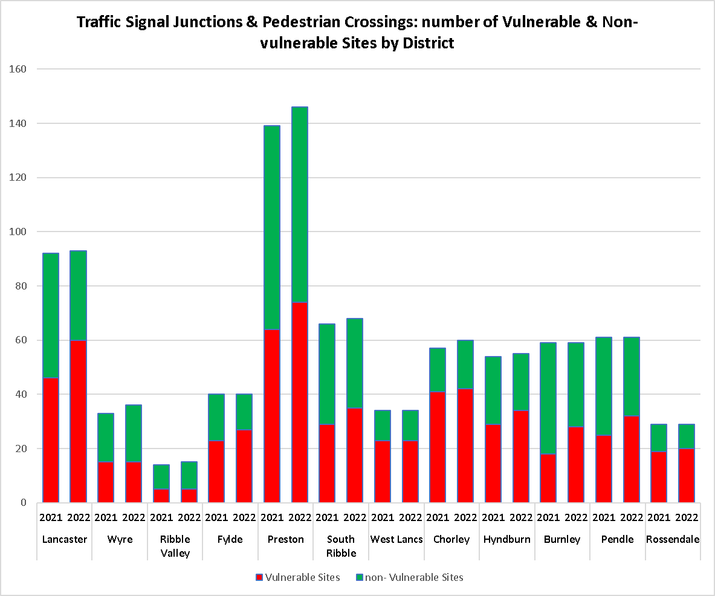

|  |
| --- |
|  |

**Summary**

* Baseline for comparison is 2021 as the new traffic signal service standard was agreed in December 2020
* There are 696 traffic signal installations in Lancashire
* The condition of the stock is measured in terms of the vulnerable sites, which refers to installations that are older than their 20-year design life and additionally have obsolete controllers age both of which are no longer supported by the manufacturer.
* We currently have a total of 395 installations (56.75% of the stock) which are classed as vulnerable.
* The condition of this asset type is considered to be POOR
* A breakdown of vulnerable sites traffic signal and pedestrian crossing sites by district is shown in the graph above.
* It is anticipated that without significant investment, the condition of this asset type will remain POOR at the end of Phase 2 in March 2025.
* It is estimated that a replacement programme at a value of £2.2m per year to improve the condition of this asset group to ACCEPTABLE by the end of TAMP Phase 3
* Currently undertaking asset inventory review – to be updated by March 23
* As of 2018 the UK began the phasing out of halogen bulbs. The authority has over 10,000 halogen bulbs on the network which will take significant capital investment to replace which will also save Carbon; an investment plan is being prepared.

1. **Service Standards**

The Service Standards in the TAMP are derived wherever possible from condition data collected by engineering analysis and is used to: -

* Monitor the overall condition of assets,
* Monitor our year on year performance, and
* Compare overall progress against the targets contained in the main TAMP document.

As more condition data becomes available for more asset groupings the performance targets will be updated as appropriate and will be included in a future TAMP refresh documents.

Where it is necessary to change service standard, we will clearly explain why such changes are required and obtain the necessary Member approval.

The main TAMP Phase 2 document identifies 5 service standards of POOR, ACCEPTABLE, FAIR, GOOD and EXCELLENT, against which the benefits to the users of the asset can be measured. Details of the generic levels of service that each of the transport asset groups are likely to provide to users at each service standard are contained in Appendix 1 of the TAMP Phase 2 document which can be accessed [here](https://www.lancashire.gov.uk/council/strategies-policies-plans/roads-parking-and-travel/highway-asset-management-in-lancashire/strategies/transport-asset-management-plan/tamp-phase-2-201920-202324/).

The condition data contained in this data refresh document enables us to compare our performance against the baseline figure contained in the TAMP and our direction of travel.

The TAMP set an overall indicative service standard target of GOOD to be achieved at the end of period 2020/21-2024/25. In setting an overall indicative service standard target of GOOD it is recognised that it is not possible or affordable to maintain all asset groups to the same level. The targets for individual asset groups have, therefore, been set according to county council priorities, risk and affordability.

The overall condition of the transport infrastructure asset has been determined by assigning scores to each service standard. A weighted score has been produced by multiplying each score by the asset valuation. A weighted average is calculated by dividing the total weighted scoring by the total value of the asset, as detailed below

|  |  |  |  |  |
| --- | --- | --- | --- | --- |
| **Scores per Service Standard** | | | | |
| **POOR** | **ACCEPTABLE** | **FAIR** | **GOOD** | **EXCELLENT** |
| **1** | **2** | **3** | **4** | **5** |

We are no longer required to collect Whole of Government Account information for highways. Therefore, for consistency purposes and to allow us to monitor progress against the start of the TAMP in April 2015, we will continue to use 2018/19 data throughout Phase 2 of the TAMP.

**Asset Condition Summary March 2022**

The initial TAMP assessed the service standard to be 2.26 which determined the transport asset to be in an ACCEPTABLE condition. As a result of this data refresh the condition of the service standard has been calculated at 3.11 which places us near the bottom of FAIR. In 2021 the new service standards were introduced and the Asset Condition Summery now reflects these changes. For the 2021 assessment the unclassified roads, footways and Street Lighting were incorrectly assessed, this has now been adjusted and the Service Standard Score for 2021 (original and adjusted) and 2022 can be seen below. The full scoring matrix for 2022 can be seen on the next page.

|  |  |
| --- | --- |
| **Service Standard Score** | |
| **2021** | **2.06** |
| **2021 corrected** | **3.24** |
| **2022** | **3.11** |

As the unclassified roads are our largest and valuable asset we will only be able to bring about significant overall improvements once the conditions of this asset improves.

According to the general service standards set out in Appendix 1, of the TAMP Phase 2 document which can be accessed [here](https://www.lancashire.gov.uk/council/strategies-policies-plans/roads-parking-and-travel/highway-asset-management-in-lancashire/strategies/transport-asset-management-plan/tamp-phase-2-201920-202324/), our highway and transport asset network should be regarded as being generally free from critical safety defects, although considerable maintenance backlogs do exist which have accumulated, in general, due to insufficient resources being made available over a period of time to maintain the whole asset base.

**Asset Condition Summary March 2022**



|  |  |  |  |  |
| --- | --- | --- | --- | --- |
| **Overall Service Standard – Grade Boundaries** | | | | |
| **POOR** | **ACCEPTABLE** | **FAIR** | **GOOD** | **EXCELLENT** |
| **1 to 1.9** | **2 to 2.9** | **3 to 3.9** | **4 to 4.9** | **5** |



1. **Conclusion**

By tracking condition data it has been shown that a change in approach from 'worst first' to a preventative maintenance regime has already had a big impact particularly on the A, B and C road network which has seen the condition of many roads in a number of district areas improve to at least those enjoyed in 2012, as measured by the % or RED or AMBER roads across this network.

A change in approach from allocating funds on a district basis purely according to asset numbers/lengths and worst first in favour of a countywide approach where funding is based on need, as determined by the relevant condition data, and adopting a preventive strategy has normalising the condition of each asset grouping across Lancashire. This approach needs to be continued so that all our residents and service users are able to benefit from the same service standard regardless of district area.

Due to continued pressures from the DfT the county council cannot afford to stand still. It needs to continue to adapt and evolve if it is to secure the same or increased level of funding as it does now. Failure to attract sufficient funding will threaten the county council's ability to apply the TAMP principles in future years.

Using a risk-based approach and lifecycle modelling has significantly enhance the county council's knowledge of the condition of assets and enables us to continue scenario planning so that we are able to assess future maintenance costs and plan the best way to manage all assets in the future. We still face many challenges as a result of insufficient funds to address the backlog

.