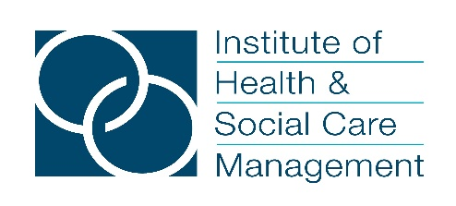
WELCOME TO THE INSTITUTE OF HEALTH & SOCIAL CARE MANAGEMENT
As a member you will have access to a whole host of benefits including:
- An exciting and challenging personal development programme
- Invitation to join special interest groups
- A full calendar of events
- Our daily news updates and weekly newsletter
- Networking/member support opportunities
To join us please complete the application process below.
Application process:
- Please visit our website: Join Us – IHSCM (ihm.org.uk)
Or scan the QR code below

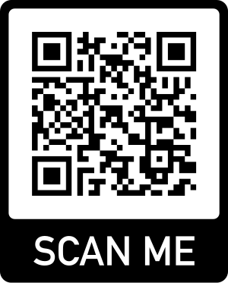

- Please complete the application form providing contact details etc
- In the very last box on the application form, labelled ‘do you have a complimentary membership code’ please enter the code ‘LSCICB’ which will allow you to bypass our usual subscription process (If you forget to enter this code and thus find yourself on the payment information page please contact us contact@ihm.org.uk and we will correct your membership record)
- You will then receive a welcome email and details of your IHSCM membership number.
If you have any questions about your membership or encounter any problems during the application process please do not hesitate to contact us
We look forward to welcoming you to IHSCM!

