***Time Activity***

9.30 Arrive and welcome, toilets, split into groups etc…

10.00 – 12.00 Group 1 - Canoeing

Group 2 - Low Ropes

Group 3 - Climbing

12.00 – 12.30 Own packed lunch

12.30 – 2.30 Group 1 - Climbing

Group 2 - Canoeing

Group 3 - Low Ropes Course

2.30 – 4.30 Group 1 - Low Ropes Course

Group 2 - Climbing

Group 3 - Canoeing

4.30 – 5.00 Goodbyes and Departure

Please note that we can design your visit to suit the times that you are able to leave school and when you need to have the young people back again. You don’t need to stay from 9.30am – 5pm to be able to do a great programme

We will endeavour to fulfil this programme; however, sometimes circumstances beyond our control will mean we have to make changes with little or no notice.

For more information on Borwick Hall please visit:

www.lancashire.gov.uk/education/outdoor/**borwick**

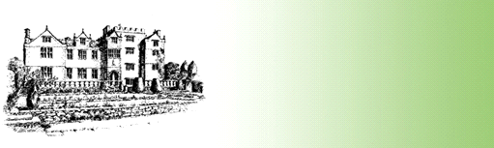

Example of a Primary Day Visit Programme

Mr Smith

Wednesday 3rd June

36 young people and staff

Years 5 and 6

Borwick Hall