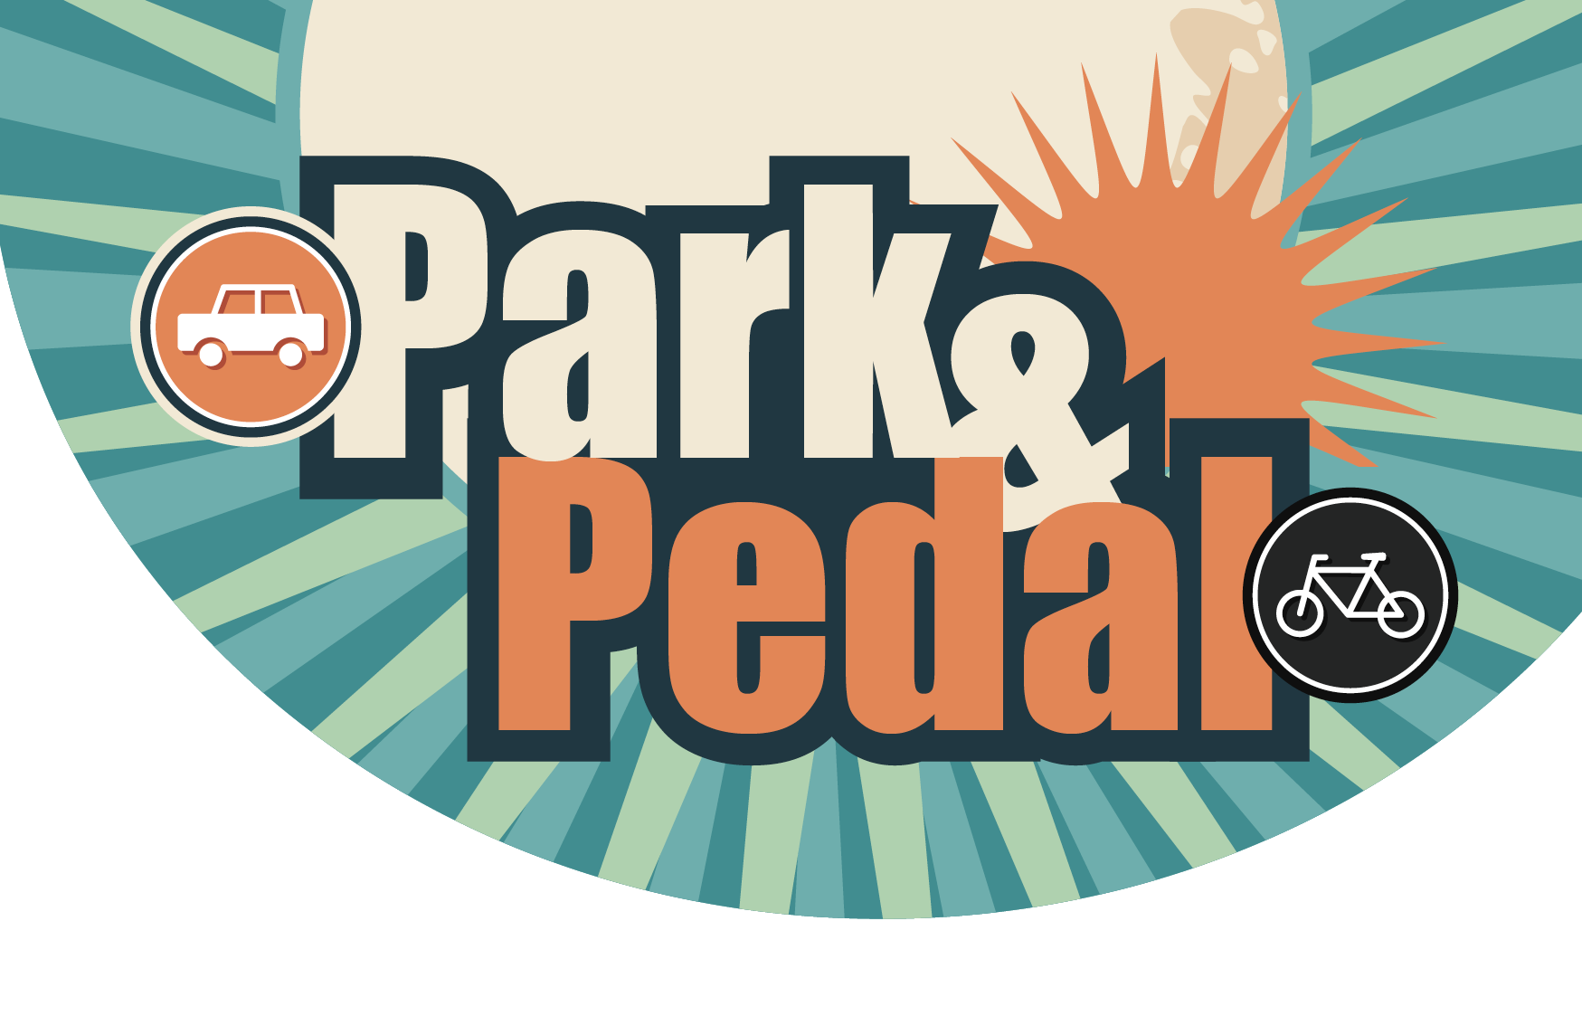**Park & Pedal - Registration Form**

**Full Name:**

**Primary Vehicle Reg:**      **Vehicle Make/Model:**       **Colour**

**(Alternative)Vehicle Reg:**       **Vehicle Make/Model:**       **Colour**

**Home Postcode:**       **Workplace Postcode:**

Please tick box to indicate preferred method of contact

**Contact Details  Telephone:**      

**Mobile:**      **Email:**      

**Anticipated frequency of days you Mon**  **Tues**  **Weds**  **Thurs**  **Fri**

**expect to use the Park and Pedal scheme: Ad hoc**

**Declaration by applicant:**

I hereby declare that the above particulars given are true and correct. I have read, understood and agree to abide by the terms and conditions of the Park & Pedal Scheme.

**Signed:_______________________________ Print Name:**       **Date:**      

Please return your completed registration form to:

Sustainable Travel Team

Lancashire County Council, Room D6, County Hall Preston Lancashire PR1 0LD

Or [sustainabletravel@lancashire.gov.uk](mailto:sustainabletravel@lancashire.gov.uk?subject=Park%20and%20Pedal%20Registration)

**For Office Use Only**

Processed by:_     ______________ Approved by:      ___________________Date_     ____________

**For Office Use Only**

Processed by:___________________________ Approved by:___________________________Date___________________