SESSION EIGHT - INFORMATION SHEET TWO
Group Two
In some areas of Lancashire activity called the Community Alcohol Network is carried out. ASB police patrol on Friday and Saturday nights finding young people who are drinking on the streets.
Do you think this is something that young people should support?
‘Unsupervised drinking by young people under 18 in public places has the closest links to crime and anti-social behaviour, as well as putting young people at risk in other ways – this is unacceptable’ – Youth Alcohol Action Plan (2008)

Community Alcohol Networks
Aims
- To reduce:
  - young people's access to alcohol;
  - binge and risky drinking
  - alcohol fuelled anti social behaviour amongst young people
  - alcohol sales to young people
- To raise awareness of alcohol related health and social issues amongst young people, parents and the wider community.
- Engage with young people around alcohol issues including signposting to diversionary activities and raise awareness of support services.
Objectives to reduce:
- The supply chains of alcohol to under 18s
- The risk to young people who are drinking alcohol in public places
- The risk of young people becoming the perpetrators or victims of crime

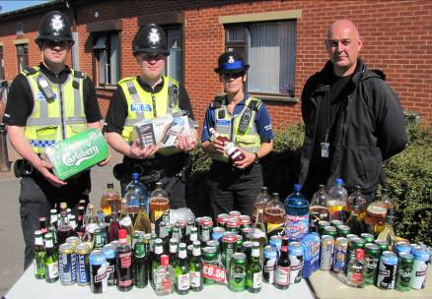
Police have the power to confiscate alcohol from under 18s drinking in public places (e.g. on the street or in parks)
This photograph shows some of the alcohol confiscated in a recent CAN operation.
The table below shows the types and amounts of substances confiscated over a 3 month period

Quarterly (3months) results of a typical CAN operation

1 | Alcohol seized - beer/cider | 255 litres
2 | Alcohol seized - spirits | 10 litres
3 | Youth referrals to under 18's | 107
4 | Young people drinking alcohol taken home | 34
5 | Young people drinking alcohol collected by parents | 105
6 | Cannabis warnings | 3
7 | Number of visits to licensed premises | 140
8 | Number of young people engaged | 1513

