SESSION SEVEN: WORKSHEET THREE
A Can Full of Nothing ….. Character descriptions
Female Characters
ELISHA: 16 years old
She is confident, easy to get on with and has lots of friends. Her best friend is Beth who she has known since primary school. Elisha leads a very busy life she has been practising judo since the age of 11 and enjoys entering competitions. Alcohol does not play a very important role in Elisha's life. She does not allow herself to be influenced or pressured by her friends and likes to make her own decisions. She thinks it's cool to be in control.
BETH: 15 years old
She likes to party and often spends the weekends drinking with Donna, Jade and Lisa. She is best friends with Elisha who she has known for years. She often teases Elisha about her attitude to alcohol and not joining in with the weekend binges with the girls. Beth has recently started seeing Harry who is much older than her, he is 27. Beth is very easily influenced and is flattered that someone like Harry is paying her so much attention and giving her gifts - even if sometimes they are drugs!! Harry is encouraging her to experiment with these drugs.

MALE CHARACTERS
NICK: 17 years old
He is in his first year of an engineering apprenticeship and he is working and studying hard to qualify. Nick is a really friendly guy and has lots of friends that he likes to look out for, especially Tom who has been taken advantage of in the past. He enjoys sport and keeping healthy and is really keen on his workout sessions in the gym. Alcohol does not play an important part in his social life but he doesn't mind his mates drinking. He is saving his money to buy a motorbike.
TOM: 17 years old
He is good friends with Nick and is studying at college; he would like to go on to university to train to be a social worker. Tom is quiet, sensible and is very popular amongst the other lads as he has passed his driving test and has access to a car. When he is driving he doesn't drink alcohol. Tom is a worrier and has been taken advantage of in the past. Nick has always been extremely protective of Tom and always makes sure he looks out for him.
STEVE: 17 years old
He likes to think he is one of the lads; he likes to have a laugh and mess around. His favourite past time is getting wasted with his mates and chilling out which he does every weekend. Steve is a mate of Nick's but is often quite critical and challenging about Nick's decision to not drink lots of alcohol and get drunk with the rest of the lads.

HARRY: 27 years old
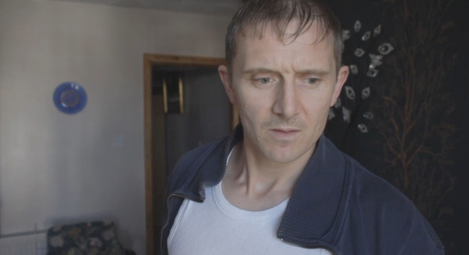
He hangs around with a younger peer group. He has a bit of a reputation for using violence, drugs and generally intimidating people. He has become interested in Beth recently despite being much older than her and has been hanging around the school, he has given her a mobile phone then he can stay in touch with her. He likes to be in control and is used to everyone doing as he says. He's known locally by his nickname, 'Dirty Harry'.

